Trends In Review 2025:

A Review of Social Trends in the Red Deer and District Area
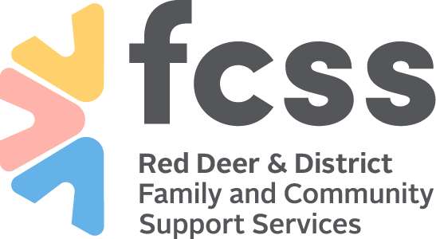

Executive Summary
The Red Deer & District Family and Community Support Services (FCSS) partnership is undertaking its regular priority setting process to identify funding priorities for the 2027-2029 funding cycle. This report is a compilation of current trends in health and social wellbeing within the Red Deer & District FCSS partnership boundaries and is meant to help inform priority selection. Various databases, literature, research papers, and websites were reviewed for data from the catchment area and Alberta generally. The literature review and the participatory compilation led to the following six themes, each of which must be considered in both the rural and urban context of this FCSS region.
Connectivity & Isolation: The Covid-19 pandemic has often been linked to increased loneliness and isolation. Now five years after the onset of the pandemic, data continues to show limited social interaction, desire for more connection, and the impacts of loneliness on health.
Cost of Living: Impacts of inflation are seen across Central Alberta. In 2024, the Social Diversion Team responded to over 9 calls per day, with at least one of those calls specific to a lack of access to basic needs. This puts demand and strain on local services, particularly food banks and supportive housing.
Youth Well-Being: While trends in youth data are reflective of trends in the general population. However, the social positioning of youths impacts possible solutions for the issues observed. Youth show indications of low social connection, increased substance use, and poor mental health.
Mental Health & Addictions: Also significantly impacted by the pandemic, data indicates a continuous decline in mental health in Central Alberta. Dispensation rates of anti-anxiety and antidepressants continue to increase, as does the use of illicit and illegal substances. This has knock-on effects on the health and justice systems.
Healthy Living: Data indicates that the expected lifespan of Central Albertans is 1.48 years shorter than the general Albertan. Adverse health outcomes such as diabetes and hypertension rising, while access to health care becomes more challenging. Healthier options may be limited by increased cost of living.
Safety & Violence: Despite drops in most crime categories, many people rate crime and safety as a top concern. Central Alberta had nearly 3000 requests for support from children and youth who had experienced victimization between 2020 and 2023. Long-term impacts of COVID-19 lockdowns on domestic violence remain to be seen.

Table of Contents
Executive Summary 2
Red Deer & District 4
Introduction and Objective 4
Process and Approach 4
Regional Demographics 6
Regional Population 6
Age Distribution 7
Connectivity & Isolation 8
Cost of Living 10
Youth Well-Being 12
Mental Health & Addictions 14
Healthy Living 15
Family & Sexual Violence 16

Red Deer & District
The Red Deer & District FCSS partnership catchment is in Central Alberta, the approximate midpoint between Calgary and Edmonton. The partnership consists of six municipalities: the City of Red Deer, Red Deer County, the Town of Bowden, the Village of Delburne, the Village of Elnora, and the Town of Penhold. This region serves key industries, including Health Care and Social Assistance, Retail Trade, Construction, Manufacturing, Accommodation and Food Services, Oil and Gas, and Educational Services.
This region is the historic and current homeland of many Indigenous Peoples. The land on which the Red Deer & District FCSS partnership resides is the traditional land of Treaty 6 First Nations (the Cree, Dene, Blackfoot, Saulteaux, and Nakota Sioux), Treaty 7 First Nations (the Blackfoot Confederacy, Kainai, Piikani, Siksika, T’suut’ina, and Stoney Nakoda), and Métis ancestral lands.

Introduction and Objective
The 2025 Trends in Review report is a compilation of current social trends of wellbeing in Alberta, with a specific focus on the catchment area of the Red Deer & District FCSS partnership. This report includes data and information available since 2016 to the most recent available year, which varies by data source. The 2025 Trends in Review report aims to provide background information to stakeholders in the FCSS 2027-2029 funding priority setting process.

Process and Approach
The creation of this report started with a literature review and compilation of relevant data on the general wellbeing trends in Central Alberta, or Alberta generally where more specific information was not available. The FCSS Research and Evaluation Team (R&E) looked for data that was relevant to community wellbeing, timely in its availability, and publicly available.
To further organize this data, FCSS staff (FCSS community facilitators, workers, navigators, and project leaders from each region in the FCSS district) were engaged in meaning making using an approach called card sorting. Visuals were created using the available data, then cut into separate pieces (the “cards”) and provided as a set to teams of FCSS staff. The teams were then asked to use this data to build the story of the region over the past three years.
These cards were launching points to discuss local trends based on the wellbeing FCSS staff see in their communities. Participants were also asked to identify any missing or additional data needed to paint a more accurate picture of their communities, as well as any data they felt was irrelevant and could be removed.
At the end of the activity, each team had identified significant themes and created several groupings and visuals based on what they had discussed. Secondary analysis of the results was done by R&E to identify major themes, connecting points, and differences across groups. This information was used to create the final version of this report.
The participatory approach of card sorting worked to ensure that the experiences of front-line workers in the Red Deer & District FCSS Partnership area were reflected in the understanding and presentation of the available data. FCSS community workers and facilitators have first-hand experience of working with our communities and have an on-the-ground understanding of community assets and needs.

Community-Based Assets
For the first time, priority setting for this funding cycle included a community-based asset inventory exercise. During the consultation, FCSS staff were asked to create cards listing different assets, which community they serve, and up to three of the 2026 Family and Community Support Services Association of Alberta (FCSSAA) Accountability Framework Provincial Prevention Strategies the asset most aligns with. Following the card sort, they were asked to place their asset cards on the theme that the asset would be most beneficial to.
Between four groups, 65 community-based assets were listed, ranging from physical spaces, citizen attitudes, support resources, and partnerships. Some overlap existed where the same kind of asset was listed for multiple different communities (e.g. schools). While this exercise was brief and an extended version of it could be its own source of rich information, the data gathered provides some interesting insights.
The 2026 FCSSAA Accountability Framework outlines six main prevention strategies:
- Promote and encourage active engagement in the community
- Foster a sense of belonging
- Promote social inclusion
- Develop and maintain healthy relationships
- Enhance access to social support
- Develop and strengthen skills that build resilience.
From the assets identified, fostering a sense of belonging was the most frequently listed strategy (n=35) followed by promoting and encouraging active engagement in the community (n=25), and promoting social inclusion (n=22).

Regional Demographics

Regional Population

Age Distribution

Connectivity & Isolation
The ways we connect and interact with others in our communities have changed following the Covid-19 pandemic. More than 10% of Canadians aged 15 and older reported often or always feeling lonely. Social isolation and loneliness have been linked to serious impacts on physical and mental health, quality of life, and longevity. This is increasingly being recognized as a priority public health problem.
With the exceptions of Red Deer County and Penhold, all communities in the Red Deer & District FCSS area have more people living alone than the provincial and national averages. About one in four people living alone reported often or always feeling lonely, double that of those who live with others in their household.
Canadians report feeling a lack of time, specifically noting that they worry about not spending enough time with family or friends, while also wanting more alone time.
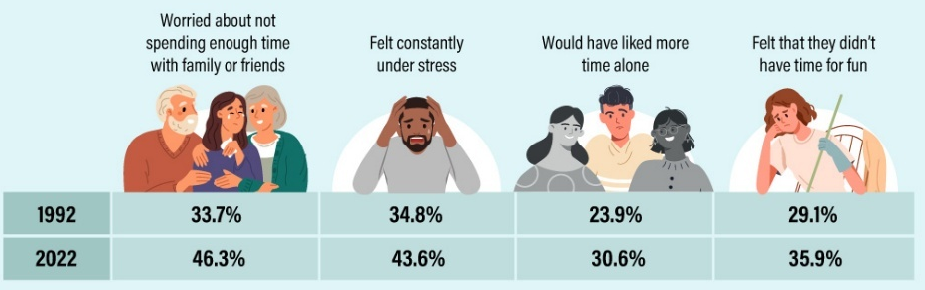
The International Federation on Ageing states that “the number one emerging issue facing seniors in Canada is keeping older people socially connected and active”. In 2013, Seniors made up about 15% of the Canadian population. By 2036, this group is expected to be between 23-25%. By 2038, there will be two seniors for every five working-age adults. Currently, one in five Canadian seniors report experiencing loneliness, with women more likely to report being lonely than men.
Red Deer & District FCSS volunteer rates decreased significantly due to the Covid-19 pandemic. In the years since, rates have steadily increased, though they remain below 2019 rates. This is consistent with national trends, with the percentage of people volunteering decreasing 6% between 2018 and 2023.

Cost of Living
Between January 2024 and January 2025, unemployment rates remained stable, dropping by 0.2% in the Red Deer region, with a rate of 7.9% in 2025. This rate is higher than both the provincial (6.7%) and national (6.6%) unemployment rates. However, this rate is nearly half of its high of 15.0% in July 2020, when unemployment rates spiked across the country due to the Covid-19 pandemic.

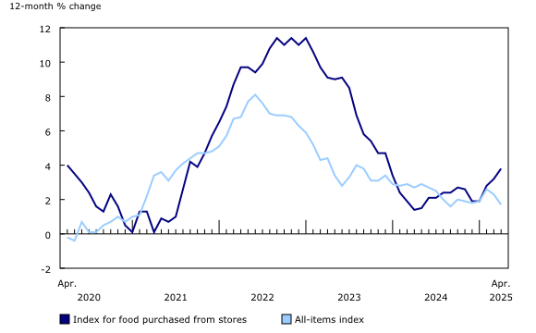
The Alberta Living Wage Network suggests that Red Deer’s minimum wage needs to be $18.90/hour to ensure people can “thrive, participate in their communities, and manage unforeseen expenses.” In 2024, the Red Deer Social Diversion Team responded to 3,311 events, 11% (364) were for basic needs requests like food or warm clothing. This is equivalent to one call each day for basic needs. A quarter of the calls made to 211 from Red Deer were also for support with basic needs, most being housing-related.
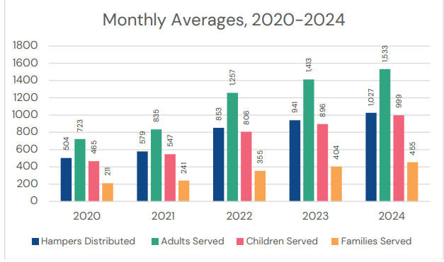
While most products have been subject to high rates of inflation, the inflation of food products has been felt by many families in Central Alberta. As of April 2025, food purchased from stores has seen a 3.8% year-over-year increase, consistently increasing faster than the all-items index. Fresh or frozen beef (+16.2%), coffee and tea (+13.4%) were the largest contributors to year-over-year acceleration.
The increase in food prices is felt by emergency food providers, like the Red Deer Food Bank. Located in the City of Red Deer, the Food Bank assists with nearly 40 additional helping organizations in Central Alberta, with a service area of 22,000km²⁽⁾. A $100 emergency food hamper made in 2020 would cost the Food Bank $122.5 at the end of 2024. In the same period, the Food Bank saw an increase in demand of over 80%.
The increase in the cost of living has also been felt through an increase in people experiencing homelessness or housing insecurity. Between 2022 and 2024, the City of Red Deer saw a 235% increase in the number of people experiencing homelessness. With increased house and rent prices, more new adults live with at least one parent. Such costs may cause additional strain on single parent households. The Red Deer & District area generally has more single parent households and fewer 20–34-year-olds living with at least one parent than provincial and national averages.

Youth Well-Being
Many of the trends seen among youth are reflective of greater trends. With many different issues affecting local youth, youth well-being has been identified as its own theme, though different trends are tied to other themes explored in this document.
Two in five Red Deer youth report using social media for more than three hours each day, with an additional two in five spending one to two hours per day. Only 18% reported using social media for less than one hour each day. Two-thirds of the same group of youths reported having experienced bullying online.
Regarding connections, 23% of youth aged 15 to 24 report feeling often or always lonely. Reported loneliness decreased as age category increased, indicating youths are the most likely to feel lonely. Red Deer youth were asked about their connections at school. Most youth agreed that they had friends (84%) or adults (68%) at school that cared about them. Fewer reported getting along with teachers at their school (64%), while about one in five reported that they do not get along with teachers at their school.
Alcohol is the most widely used substance used by youths in grades 7 – 12, with 22% using in the past 30 days. This is followed by vapes (15%) and cannabis (12%). Nearly two-thirds of Canadian youths in grades 10-12 report that cannabis is easy or very easy to obtain, with males first using at 16.8 years old and females at 17.2 years old.
Three in five (61%) of Red Deer youth report having a positive perception of their physical health, while only one in three (36%) report the same for their mental health. Over a quarter of youth (27%) negatively perceive their mental health, compared to only 14% for physical health. Emergency department visits for self-inflicted injuries are heist among those 15–19 years old, at a rate of 1049 per 100,000, nearly double the next highest age group (20-24).

Mental Health & Addictions
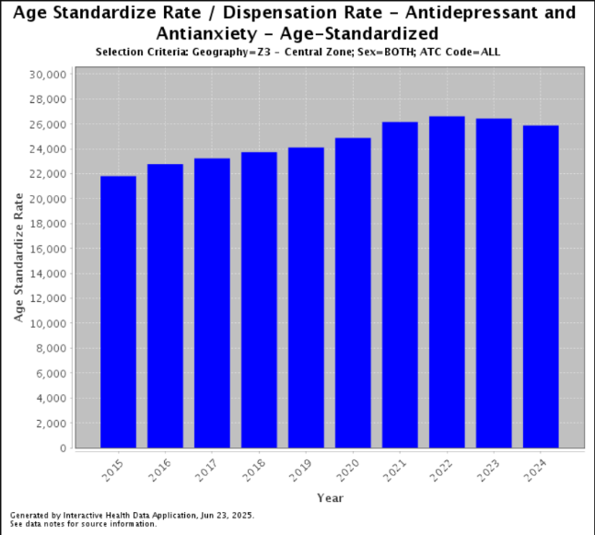
The Covid-19 pandemic has been linked to an overall decline in mental health, with the World Health Organization reporting a 25% increase in the prevalence of anxiety and depression worldwide in the first year of the pandemic. Now five years after the onset of the pandemic, mental health impacts continue to be felt in Central Alberta.
Despite a decrease in dispensation rates of antidepressant and antianxiety medications since 2022, rates remain above pre-pandemic rates. Of those that received mental health care in the previous year, 44% reported that their needs were not fully met. In 2020, one in four Canadians reported not being happy and interested in life.
Suicide rates in Alberta are 14.3 deaths per 100,000, higher than the national average of 10.9/100,000. Suicide rates are higher among First Nations and rural communities with limited access to mental health care and supports.
Though rates dropped between 2023 and 2024, the overall trend of overdose deaths continue to climb , as do substance use related emergency department visits.

Healthy Living
On average, the life expectancy at birth is 1.48 years shorter for Central Albertans than for Albertans generally.
In both 2022 and 2023, 75% of Albertans reported not receiving health care when they felt it was needed. In 2023, 17% of Central Albertans did not have a family doctor. Though there was a one-percent decrease from the previous year, the number of people with a family doctor is trending upwards.
Between 2018 and 2023, the proportion of overweight Central Albertans rose from 6%, from 63% to 69%, with a high of 71% in 2020. At the same time, the number of Central Albertans reporting that they consume the daily recommended amount of fruits and vegetables has steadily decreased from 43% in 2018 to 35% in 2023. With the impact of inflation (see “Cost of Living” above) prices may factor into decreased consumption of produce.
Rates of other adverse health outcomes, such as diabetes and hypertension have been consistently increasing since the early 2000s.

Safety & Violence
Between 2023 and 2024, overall crime rates have dropped in the Central Alberta region,. Despite this, one in five people in Red Deer listed crime and safety as a major challenge to living in the area. In the same survey, 37% thought of Red Deer as “somewhat less safe than other communities”,12% found it “very unsafe”, and 59% felt that feelings of safety have decreased in the previous two years.
When asked about experiences of discrimination, 27.9% of those identify as part of a visible minority, 27.3% of Indigenous people, and 18.8% of those with activity limitations had experienced discrimination. Referring to the previous 12 months, 37% of Red Deer citizens (or a member of their family) had been the victim of a reportable crime. Of those that were victimized, 32% chose not to report the crime to the police.
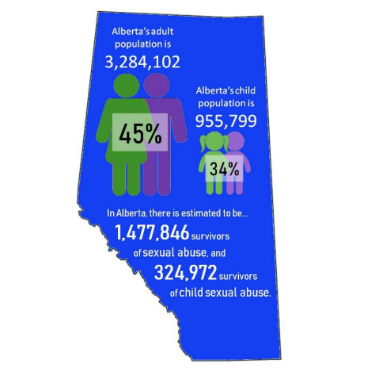
Alberta has the second-highest rate of maltreatment (experience of or exposure to physical, sexual, or emotional abuse or neglect) in the country, with 67.5% reporting experiencing such treatment before age 15. The Canadian average is 59.7%. Between 2020 and 2023, 2,769 children and youth sought support from the Central Alberta Children’s Advocacy Centre abuse experiences. Red Deer children made up 35% of these cases, indicating the broad spread of this issue across the area.
Prior to the Covid-19 pandemic, it was estimated that about 1.5 million survivors of sexual abuse and 325,000 survivors of child sexual abuse live in Alberta. Early into the pandemic, one in ten Canadian women reported being “very or extremely concerned about the possibility of violence in their home”. By May, one in five Indigenous women had experienced domestic violence since the pandemic began. Many shelters for victims of abuse saw increases in demand for their services through the pandemic. Long-term data on the impact of lockdowns on domestic violence remains to be seen.

The City of Red Deer. Key Industries. https://www.reddeer.ca/business/business-environment/key-industries/
Statistics Canada. Focus on Geography Series, 2021 Census of Population. https://www12.statcan.gc.ca/census-recensement/2021/as-sa/fogs-spg/index.cfm?Lang=E
Statistics Canada. Focus on Geography Series, 2021 Census of Population. https://www12.statcan.gc.ca/census-recensement/2021/as-sa/fogs-spg/index.cfm?Lang=E.
Statistics Canada. Canadian Social Survey: Loneliness in Canada. Released November 24th, 2021. https://www150.statcan.gc.ca/n1/daily-quotidien/211124/dq211124e-eng.htm
World Health Organizations. Social isolation and loneliness. 2025. https://www.who.int/teams/social-determinants-of-health/demographic-change-and-healthy-ageing/social-isolation-and-loneliness
Statistics Canada. Focus on Geography Series, 2021 Census of Population. https://www12.statcan.gc.ca/census-recensement/2021/as-sa/fogs-spg/index.cfm?Lang=E
Statistics Canada. Canadian Social Survey: Loneliness in Canada. Released November 24th, 2021. https://www150.statcan.gc.ca/n1/daily-quotidien/211124/dq211124e-eng.htm
Statistics Canada. Pressed for time. Released June 17, 2025. https://www150.statcan.gc.ca/n1/pub/11-627-m/11-627-m2025043-eng.htm?utm_source=lnkn&utm_medium=smo&utm_campaign=statcan-general
Statistics Canada. Report on the Social Isolation of Seniors, 2014. https://www.canada.ca/en/national-seniors-council/programs/publications-reports/2014/social-isolation-seniors/page05.html
Statistics Canada. A look at loneliness among seniors. November 6, 2023. https://www.statcan.gc.ca/o1/en/plus/4881-look-loneliness-among-seniors
FCSS Community Reports, 2019 - 2024
Statistics Canada. Volunteering and charitable giving in Canada, 2018 to 2023. Released June 23, 2025. https://www150.statcan.gc.ca/n1/daily-quotidien/250623/dq250623b-eng.htm
Government of Alberta. Economic Dashboard, Unemployment Rate. Updated June 6, 2025. https://economicdashboard.alberta.ca/dashboard/unemployment-rate/#section7
Ibid.
Alberta Living Wage Network (ALWN). Alberta living wage network releases 2024 living wage rates in partnership with 21 communities. https://www.livingwagealberta.ca/news/alberta-living-wage-network-releases-2024-living-wage-rates-in-partnership-with-21-communities
City of Red Deer. 2024 Social Diversion Report.
211 Alberta. 211 Alberta Data Dashboard. https://ab.211.ca/how-we-help/211-data/
Statistics Canada. Consumer Price Index, April 2025. Released May 20, 2025. https://www150.statcan.gc.ca/n1/daily-quotidien/250520/dq250520a-eng.htm?indid=3665-2&indgeo=0
Red Deer Food Bank. FAQs. https://www.reddeerfoodbank.com/faqs
Red Deer Food Bank. 2023-2024 Annual Report. https://static1.squarespace.com/static/62702b7285aa176752f339d6/t/67feb82b7defa649a3aa95e5/1744746556952/2023-24+AR_FULL+REPORT.pdf
2024 City of Red Deer Point in Time Homelessness Count Report – Forthcoming
Statistics Canada. Focus on Geography Series, 2021 Census of Population. https://www12.statcan.gc.ca/census-recensement/2021/as-sa/fogs-spg/index.cfm?Lang=E
Red Deer Youth in Facilities Survey, 2024
Statistics Canada. Canadian Social Survey: Loneliness in Canada. Released November 24th, 2021. https://www150.statcan.gc.ca/n1/daily-quotidien/211124/dq211124e-eng.htm
Red Deer Youth in Facilities Survey, 2024
Government of Canada. Alcohol and drug use among students in Canada, 2023-2024. Key findings from the Canadian student alcohol and drug survey. https://www.canada.ca/en/health-canada/services/canadian-student-tobacco-alcohol-drugs-survey/2023-2024-key-findings.html
Canadian Centre on Substance Use and Addictions. Provincial patterns and trends in cannabis use among youth: Alberta. February 26, 2020. https://www.ccsa.ca/en/provincial-patterns-and-trends-cannabis-use-among-youth-alberta
Red Deer Youth in Facilities Survey.
Government of Canada. Mental health in Canada dashboard. Last updated June 20, 2024. https://health-infobase.canada.ca/mental-health/indicators/explore.html
World Health Organization. COVID-19 pandemic triggers 25% increase in prevalence of anxiety and depression worldwide. March 2, 2022. https://www.who.int/news/item/02-03-2022-covid-19-pandemic-triggers-25-increase-in-prevalence-of-anxiety-and-depression-worldwide
Government of Alberta. Interactive Health Data Application. http://www.ahw.gov.ab.ca/IHDA_Retrieval/selectSubCategoryParameters.do#
Government of Canada. Mental health in Canada dashboard. Last updated June 20, 2024. https://health-infobase.canada.ca/mental-health/indicators/explore.html
Ibid.
Canadian Mental Health Association. The state of mental health in Canada 2024: Alberta profile. https://cmha.ca/wp-content/uploads/2024/11/State-of-Mental-Health-profile-Alberta.pdf
Government of Alberta. Alberta Substance Use Surveillance System (Updated June 2025). https://www.alberta.ca/substance-use-surveillance-data#jumplinks-0
Ibid.
Government of Alberta. Interactive Health Data Application. http://www.ahw.gov.ab.ca/IHDA_Retrieval/selectSubCategoryParameters.do#
Ibid.
Ibid.
Ibid.
Ibid.
RCMP – Data – Red Deer Municipal Detachment. Retrieved July 2025. https://www.rcmp-grc.gc.ca/ab/criminal-statistics-statistiques-criminelles/red-deer-eng.htm
Government of Alberta. Alberta Justice Dashboard. https://www.alberta.ca/alberta-justice-dashboards
The City of Red Deer. What we heard report: 2024-2026 Community consultations. Released May 2024. https://www.reddeer.ca/media/reddeerca/city-services/police-rcmp/DMPROD-3312352-v1-2024-26_APP_-_What_We_Heard_Report_-_(delivered_May_2024).pdf
Ibid.
Ibid.
Statistics Canada. Economic and social reports: What do we know about physical and non-physical childhood maltreatment in Canada? Released January 25, 2023. https://www150.statcan.gc.ca/n1/en/pub/36-28-0001/2023001/article/00001-eng.pdf?st=5UyoMZNh
Central Alberta Child Advocacy Centre. State of child wellbeing in central Alberta. 2024 Community report. https://www.centralalbertacac.ca/wp-content/uploads/2024/04/CACAC-Community-Report-State-of-Child-Wellbeing-2024.pdf
Association of Alberta Sexual Assault Services (AASAS). Summary of key findings: Prevalence of sexual assault and childhood sexual abuse in Alberta. January 29, 2020. https://aasas.ca/wp-content/uploads/2022/05/Prevalence-of-Sexual-Assault-Childhood-Sexual-Abuse-Summary-of-Key-Findings_FINAL.pdf
Canadian Labour Congress. COVID-19 and the increase of domestic violence against women. June 24, 2020. https://www.ohchr.org/sites/default/files/2022-01/canada-3-labour-congress.pdf
Ibid.
Statistics Canada. Many shelters for victims of abuse see increases in crisis calls and demand for external supports in the first year of the COVID-19 pandemic. Released May 12, 2022. https://www150.statcan.gc.ca/n1/daily-quotidien/220412/dq220412b-eng.htm

